Memory Mountain Lab

Student ID _____________________
Student Name _____________________
Start Time ________________________
Finish Time ________________________

Requirements
Platform: This lab assumes that you are using Visual C++ under a 32-bit version of Windows, using Intel Pentium or Pentium-equivalent machines. The exact compiler and platform are mostly unimportant, as the lab is reasonably portable.

Get to know your Cache
This platform of Intel Pentium machines has a memory hierarchy, which includes multi level of Cache, such as L1 cache, L2 cache, and sometimes L3 Cache maybe also exist.
You can use the some tools, such as everest.exe, to find out the basic information of Cache of the computer system, which you are uings.
For example, to using everest.exe, just double-click to run it. After it makes some information collection, it will show all the information about you computer system in its frame.
The following is an example of its main frame. You can see the information about the Cache.
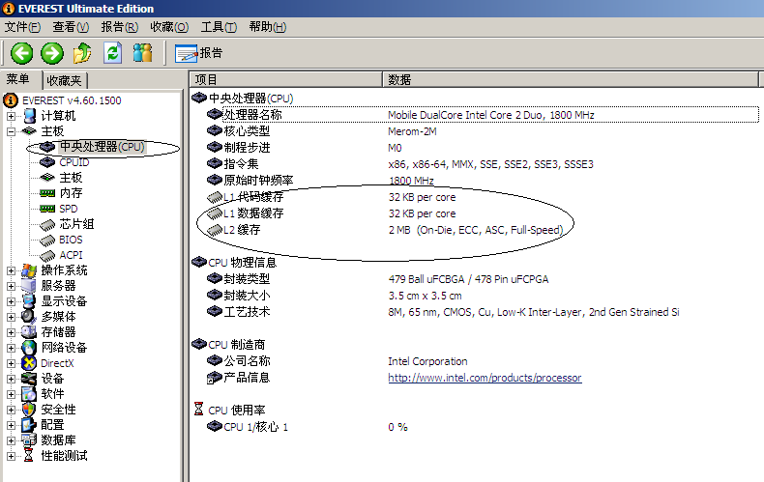

Now, run everest.exe to find out the information of your computer system’s Cache, and fill the blank.
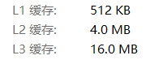
Type | Size in byte
L1 cache | 512KB
L2 cache | 4.0MB
L3 cache | 16.0MB

The project of memory_mountain
Please download the project of memory_mountain.rar first.
This project is the Windows-version of CMU CSAPP of mountain.c, which you can find in
- the textbook chapter 6.6(Notes: this is the first version),
- or from http://csapp.cs.cmu.edu/public/1e/public/code.html/mountain.c(Notes: this is the first version)
- or from http://csapp.cs.cmu.edu/public/code.html/mountain.c(Notes: this is the first version)

Your Task
1．Read the source code in mountain.cpp, and answer the following questions: (Notes: you don’t have to pay too much attention on the function fcyc2() )
1) What is the variable of size and stride used for?
size是工作集的大小，stride是每一次遍历的步长

1) What is the meaning of the return value of the function run()?
返回计算的吞吐量

2．If necessary, make some change to the value of MINBYTES, MAXBYTES, and MAXSTRIDE.
3．Build the project and run it, the you can get an output file named as out.txt.
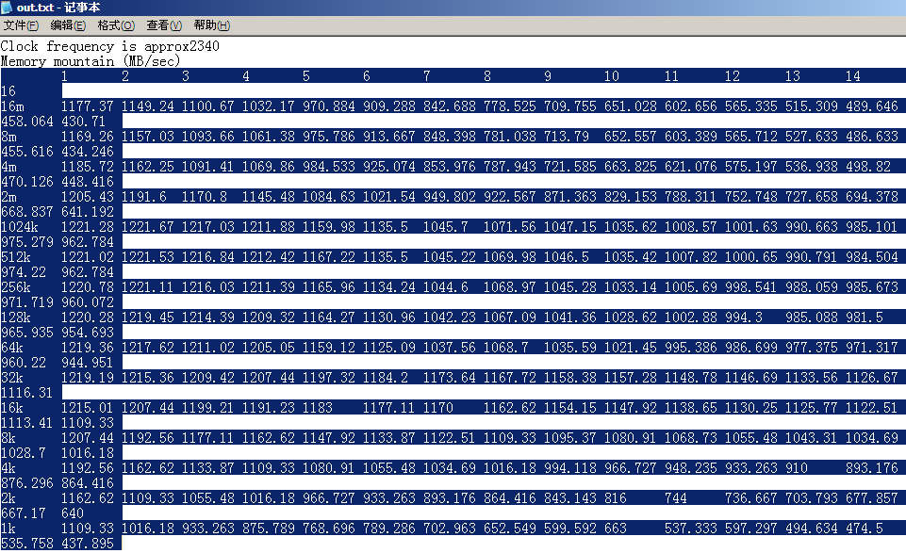
4．Copy the data in out.txt into an Excel file. Just as shown in the following figure.
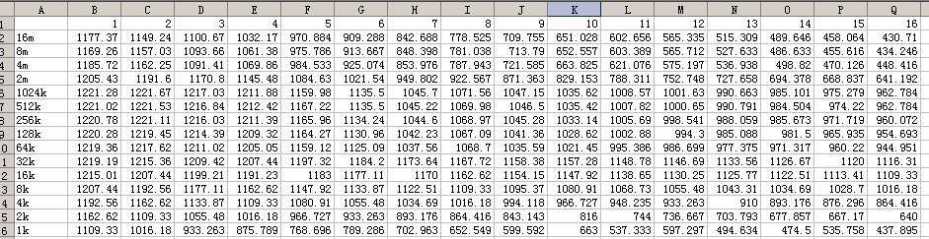
5．Click any cell in this Excel file, then add a chart.
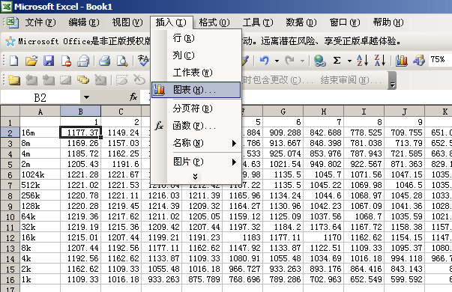

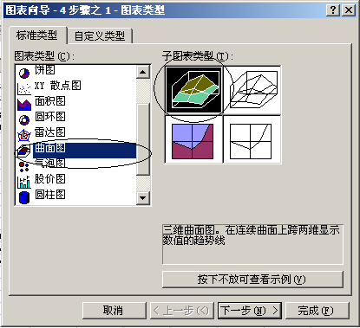

Then click Finish.

5．Then you can get a figure alike this:
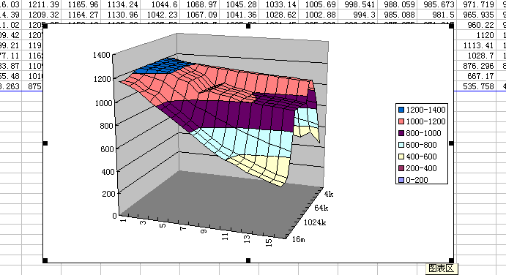

6. The following two figures are from CSAPP e1 and CSAPP e2
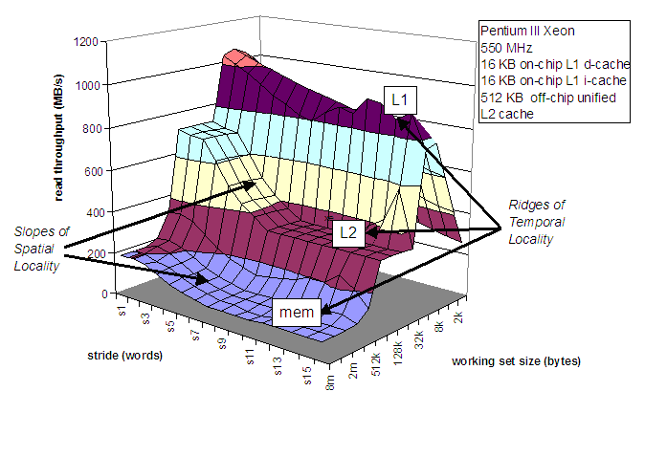
Figure of CSAPP e1

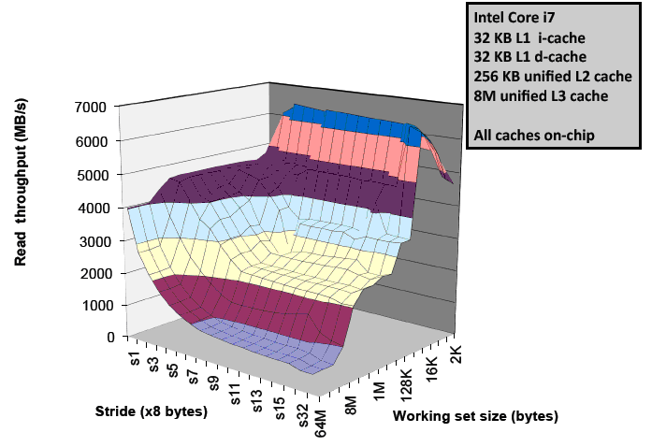
Figure of CSAPP e2

7．Just Paste your figure here:
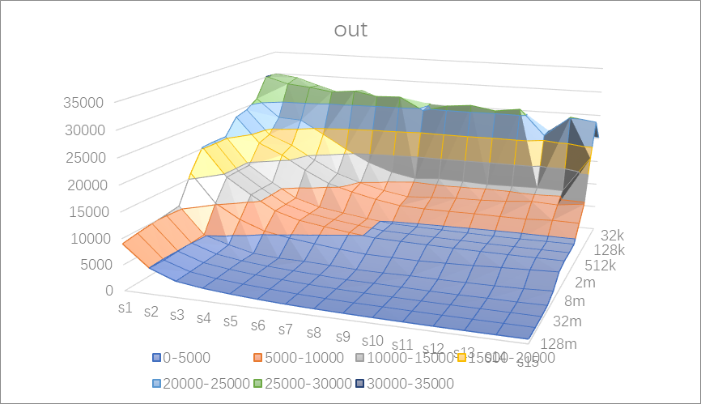

8．How many ridges(山脊) do you get? And what are they correspond to?

垂直于size轴的是四条山脊，分别对应于工作集完全在Ll高速缓存、L2高速缓存、L3高速缓存和主存内的时间局部性区域

9．Just compare the mountain with the information that you just got by running as everest.exe. And explain the How the spatial locality and temporal locality are shown in this figure.
在 L1，L2、 L3 和主存山脊上随着步长的增加有一个空间局部性的斜坡，空间局部性下降
我们看到随着size的增大读吞吐率反而减小；随着随着stride的增大读吞吐率也呈现减小的趋势；因此整个吞吐量的趋势是：size的值越小，得到的工作集越小，因此时间局部性越好。 stride 的值越小，得到的空间局部性越好

//参考资料
//https://blog.csdn.net/weixin_44307065/article/details/106251962?utm_medium=distribute.pc_relevant.none-task-blog-2~default~baidujs_baidulandingword~default-5-106251962-blog-113487877.235^v38^pc_relevant_sort&spm=1001.2101.3001.4242.4&utm_relevant_index=8

//https://blog.csdn.net/Niya0515/article/details/109865359

